**Lab Report-07**

**Title:Practice from FreeCodeCamp**

***Course Title****:*  [Web Design and Programming Lab-I](https://classroom.google.com/c/Njc5NTg4OTk0MTU0)

***Course code****: CSE-312*

*3rd Year 1st Semester Examination 2023*

**Date of Submission**:16-09-2024



**Submitted to-**

**Md. Rafsan Jani**

*Assistant Professor*

[**Bulbul Ahammad**](https://juniv.edu/teachers/bulbul)

*Assistant Professor*

[**Anup Majumder**](https://juniv.edu/teachers/anupmajumder)

*Assistant Professor*

***Department of Computer Science and Engineering***

***Jahangirnagar University***

***Savar, Dhaka-1342***

|  |  |  |  |
| --- | --- | --- | --- |
| **Sl** | Class Roll | Exam Roll | Name |
| 01 | 390 | 210910 | Abu Said Mohammad Readwanul |

* **Building A Registration Form**

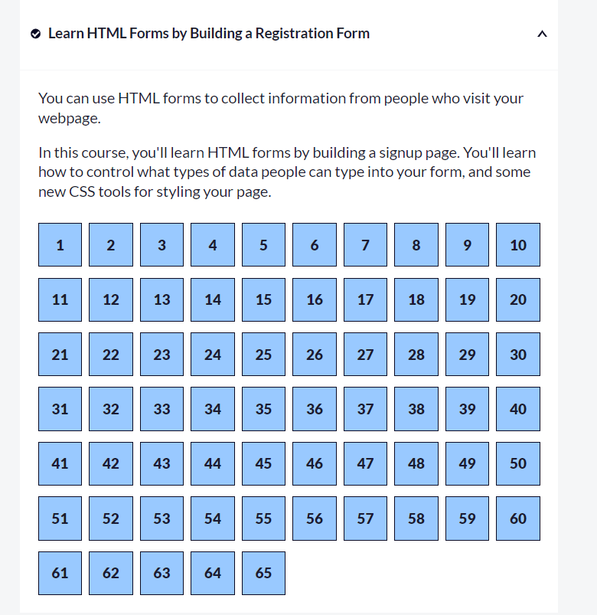

**Source Code(INDEX.HTML)**

|  |  |
| --- | --- |
| <!DOCTYPE html>  <html lang="en">    <head>      <meta charset="UTF-8">      <title>Registration Form</title>      <link rel="stylesheet" href="styles.css" />    </head>    <body>      <h1>Registration Form</h1>      <p>Please fill out this form with the required information</p>      <form method="post" action='https://register-demo.freecodecamp.org'>        <fieldset>          <label for="first-name">Enter Your First Name: <input id="first-name" name="first-name" type="text" required /></label>          <label for="last-name">Enter Your Last Name: <input id="last-name" name="last-name" type="text" required /></label>          <label for="email">Enter Your Email: <input id="email" name="email" type="email" required /></label>          <label for="new-password">Create a New Password: <input id="new-password" name="new-password" type="password" pattern="[a-z0-5]{8,}" required /></label>        </fieldset>        <fieldset>          <legend>Account type (required)</legend>          <label for="personal-account"><input id="personal-account" type="radio" name="account-type" class="inline" checked /> Personal</label>          <label for="business-account"><input id="business-account" type="radio" name="account-type" class="inline" /> Business</label>        </fieldset> | <fieldset>          <label for="profile-picture">Upload a profile picture: <input id="profile-picture" type="file" name="file" /></label>     <label for="age">Input your age (years): <input id="age" type="number" name="age" min="13" max="120" /></label>          <label for="referrer">How did you hear about us?            <select id="referrer" name="referrer">              <option value="">(select one)</option>              <option value="1">freeCodeCamp News</option>              <option value="2">freeCodeCamp YouTube Channel</option>              <option value="3">freeCodeCamp Forum</option>              <option value="4">Other</option>            </select>          </label>          <label for="bio">Provide a bio:            <textarea id="bio" name="bio" rows="3" cols="30" placeholder="I like coding on the beach..."></textarea>          </label>        </fieldset>        <label for="terms-and-conditions">    <fieldset>          <label for="profile-picture">Upload a profile picture: <input id="profile-picture" type="file" name="file" /></label>          <label for="age">Input your age (years): <input id="age" type="number" name="age" min="13" max="120" /></label>          <label for="referrer">How did you hear about us?            <select id="referrer" name="referrer">              <option value="">(select one)</option>              <option value="1">freeCodeCamp News</option> |

**Source Code(Styles.css)**

|  |  |
| --- | --- |
| body {    width: 100%;    height: 100vh;    margin: 0;    background-color: #1b1b32;    color: #f5f6f7;    font-family: Tahoma;    font-size: 16px;  }  h1, p {    margin: 1em auto;    text-align: center;  }  form {    width: 60vw;    max-width: 500px;    min-width: 300px;    margin: 0 auto;    padding-bottom: 2em;  }  fieldset {    border: none;    padding: 2rem 0;    border-bottom: 3px solid #3b3b4f;  }  fieldset:last-of-type {    border-bottom: none;  }  label {    display: block;    margin: 0.5rem 0;  } | input,  textarea,  select {    margin: 10px 0 0 0;    width: 100%;    min-height: 2em;  }  input, textarea {    background-color: #0a0a23;  border: 1px solid #0a0a23;    color: #ffffff;  }  .inline {    width: unset;    margin: 0 0.5em 0 0;    vertical-align: middle;  }  input[type=”submit”] {    display: block;    width: 60%;    margin: 1em auto;    height: 2em;    font-size: 1.1rem;    background-color: #3b3b4f;    border-color: white;    min-width: 300px;  }  input[type=”file”] {    padding: 1px 2px;  }  .inline{    display: inline;  } |

**SurveyForm**

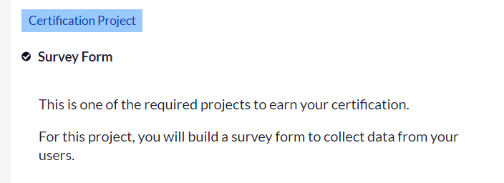

**Source Code(INDEX.HTML)**

|  |  |
| --- | --- |
| <!DOCTYPE html>  <html lang="en">  <head>    <meta charset="UTF-8">    <meta name="viewport" content="width=device-width, initial-scale=1.0">    <title>Document</title>    <link rel="stylesheet" href="`.css">  </head>  <body>    <h1 id="title">Abu Said</h1>    <p id="description">      I am a student    </p>  <form action="" id="survey-form">      <label for="name" id="name-label">Name</label>      <input type="text" id="name" placeholder="Enter your name" required>      <label for="email" id="email-label">abusaidhridoy5@gmail.com</label>      <input type="email" id="email" placeholder="Enter your Email" required>      <label for="number" id="number-label">01770396544</label>      <input type="number" name="" id="number" placeholder="Enter your number" min="7" max="11" required>  <select name="" id="dropdown"> | <option value="select">Select and option</option>        <option value="select">Bangla</option>        <option value="select">English</option>      </select>      <input type="radio" name="Name" id="" value="fruit">      <label for="fruit">apple</label>      <input type="radio" name="Name" id="" value="fruit">      <label for="fruit">orange</label>      <input type="checkbox" name="" id="" value="Test">      <label for="Test">I want to be given test </label>      <input type="checkbox" name="" id="" value="exam">      <label for="Test">I want to be given exam </label>      <textarea name="" id="">You can write you idea</textarea>      <button type="submit" id="submit">Submit</button>    </form>  </body>  </html> |